**YEAR 11 HUMAN BIOLOGY**

2010

PREGNANCY TEST

**SECTION A: MULTIPLE CHOICE – 20 MARKS**

**SECTION B: TERMINOLOGY – 10 MARKS**

**SECTION C: SHORT ANSWER – 40 MARKS**

* Answer all questions on the written section.
* No calculators will be allowed.
* Check your answers carefully.
* **Good LuckSECTION A – MULTIPLE CHOICE (20 Marks)**

1. Pregnancy normally lasts for:
   1. 240 days.
   2. 310 days.
   3. 280 days.
   4. 340 days.
2. Which of the following is not a sign of early pregnancy?
   1. Morning sickness.
   2. Abdominal swelling.
   3. Absence of menstrual periods.
   4. Breast swelling and tenderness.
3. A short time after the baby is born, the ‘after birth’ is expelled. This is the:
   1. membranous bag that contained the baby.
   2. wastes produced by the developing foetus.
   3. watery fluid and endometrium.
   4. placenta and foetal membranes.
4. After conception the main organs are established by the end of the:
   1. third day.
   2. second week.
   3. eighth week.
   4. fourth month.
5. After birth the first fluid released by the breasts is called:
   1. colostrum.
   2. primary milk.
   3. prolactase.
   4. vernix.
6. During birth the foetus passes to the exterior by way of the:

(a) fallopian tube

(b) oviduct

(c) vagina

(d) urethra

1. Unfortunately, some babies become drug addicts before they are born. This is liable to occur if the mother is taking certain “hard drugs” during pregnancy. Sudden withdrawal of the drug at birth places a terrible strain on the babies nervous system.

The drug can pass from the mothers body to the embryo’s body in significant amounts:

(a) because the mother and embryo share the same bloodstream..

(b) by diffusion through the vessel walls in the placenta.

(c) as a constituent of the original fertilised ovum.

(d) all of the above.

1. Consider the diagram below:

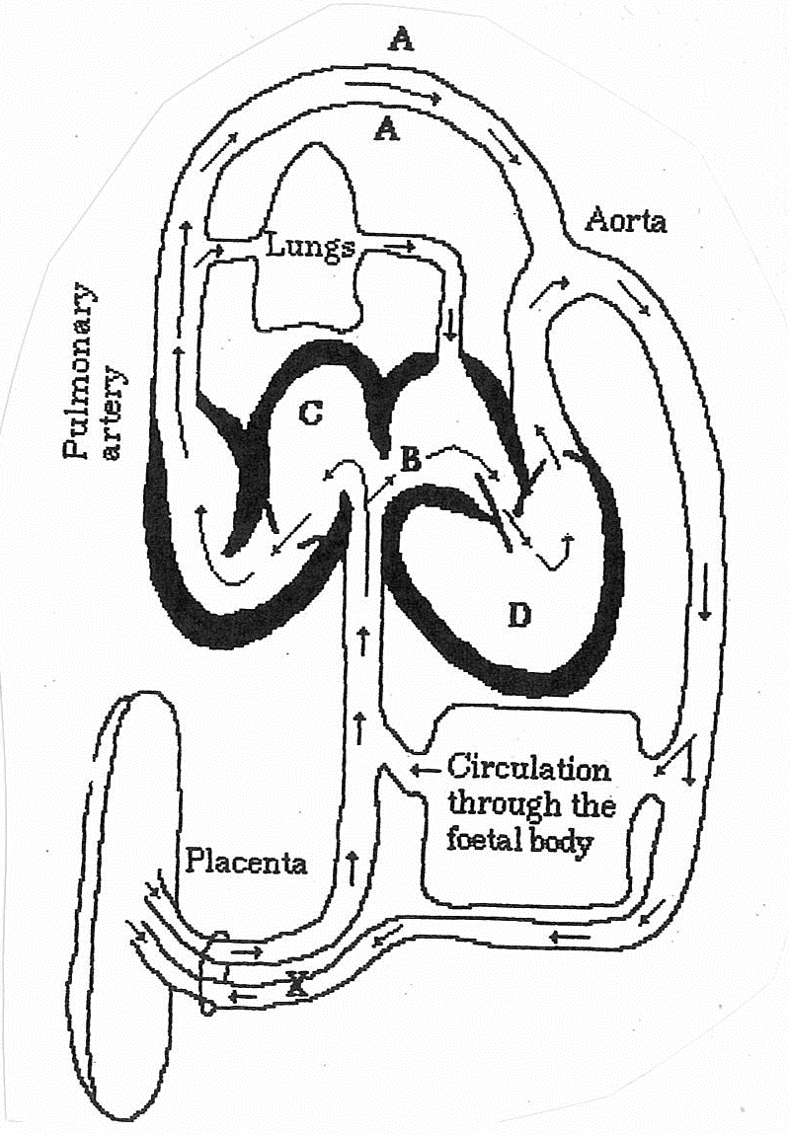

Labels **A** and **X** respectively represent:

* 1. ductus arteriosus and umbilical artery
  2. umbilical cord and umbilical artery.
  3. umbilical cord and umbilical vein.
  4. ductus venosus and inferior vena cava.

1. At the fourth month, the mother becomes very aware of the unborn child because of:
   1. a very rapid increase in size.
   2. she can sense the heartbeat.
   3. her temperature rises suddenly.
   4. it starts moving around and kicking.
2. In the stage of human development in the week immediately before birth, the developing child is called:
   1. an embryo.
   2. a blastocyst.
   3. a zygote.
   4. a foetus.
3. The hollow ball of cells which is in the uterus three or four days after fertilisation is called the:
   1. trophoblast.
   2. blastocyst.
   3. morula.
   4. mesoderm
4. The unborn child is most susceptible to viral infections and drugs which could cause malformations during the:
   1. first three months of pregnancy.
   2. period between months 3-9 of pregnancy.
   3. period between months 3-6 of pregnancy.
   4. period between months 6-9 of pregnancy.
5. The process by which a fertilised human egg becomes enclosed in the uterine wall is called:
   1. implantation.
   2. embedding.
   3. invagination.
   4. enfolding.
6. The membrane enclosing the foetus in a fluid filled sac is the:
   1. allantois.
   2. amnion.
   3. chorion.
   4. yolk sac.
7. During a normal birth:
   1. the baby adopts a breech position.
   2. oxytocin causes the uterus to contract.
   3. both the chorion and amnion remain intact.
   4. the placenta detaches before the baby is born.
8. All of the following pass freely across the placenta between the mother and foetus except:
   1. antibodies.
   2. glucose.
   3. urea.
   4. red blood cells.
9. During the nine months of pregnancy the child grows from a single fertilised egg weighing less than 1mg to a weight of between:
   1. 0 to 1.4kg.
   2. 1.4 to 2.7kg.
   3. 2.7 to 4.1kg.
   4. 4.1 to 5.5kg.
10. A maternal diet lacking in folic acid (folate) can contribute to the which of the following defects:
    1. poor bone growth.
    2. mental retardation.
    3. neural tube defects.
    4. lower than normal birth weight.
11. To maintain milk production a lactating mothers diet should have adequate supplies of:
    1. calcium, phosphate, Vitamin D.
    2. folate, iron, Vitamin A.
    3. magnesium, potassium, zinc.

(d) iodine, sodium, Vitamin C.

1. The adolescent growth spurt in males occurs between:
   1. years 11 to 13.
   2. years 13 to 15.
   3. years 15 to 17.
   4. years 17 to 19.

**END OF SECTION A**

**NAME: __________________________**

**YEAR 11 HUMAN BIOLOGY**

PREGNANCY TEST

*WRITTEN SECTION*

**SECTION A: MULTIPLE CHOICE – 20 MARKS**

**SECTION B: TERMINOLOGY – 10 MARKS**

**SECTION C: SHORT ANSWER – 40 MARKS**

* Answer all questions on the written section.
* No calculators will be allowed.
* Check your answers carefully.

**Good Luck Multiple Choice Answer Sheet**

Put a cross (**X**) next to the correct alternative.

|  |  |  |  |  |  |  |  |  |  |  |
| --- | --- | --- | --- | --- | --- | --- | --- | --- | --- | --- |
| **1** | A | B | C | D |  | **11** | A | B | C | D |
| **2** | A | B | C | D | **12** | A | B | C | D |
| **3** | A | B | C | D | **13** | A | B | C | D |
| **4** | A | B | C | D | **14** | A | B | C | D |
| **5** | A | B | C | D | **15** | A | B | C | D |
| **6** | A | B | C | D | **16** | A | B | C | D |
| **7** | A | B | C | D | **17** | A | B | C | D |
| **8** | A | B | C | D | **18** | A | B | C | D |
| **9** | A | B | C | D | **19** | A | B | C | D |
| **10** | A | B | C | D | **20** | A | B | C | D |

**SECTION B – TERMINOLOGY (10 Marks)**

Give the correct biological term for each of the following.

1. The ‘hole’ in the heart that connects the right and left atria in a foetus.

____________________________________________________________________________

2. The temporary endocrine gland in the ovary, which produces progesterone after ovulation.

____________________________________________________________________________

3. Human chorionic gonadotropin is secreted by the membrane called the;

____________________________________________________________________________

4. This hormone is involved in the milk let-down reflex.

____________________________________________________________________________

5. This blood vessel allows foetal blood to bypass the foetal liver.

____________________________________________________________________________

6. The initiation and maintenance of milk secretion is known as

____________________________________________________________________________

7. This is the period of transition from childhood to adulthood.

____________________________________________________________________________

8. The development of cells with specialised structures and functions.

____________________________________________________________________________

9. The process of an infant learning to behave in a manner that is accepted by other people.

____________________________________________________________________________

10. Defects or diseases which are present at birth.

____________________________________________________________________________

**SECTION C – SHORT ANSWERS (40 Marks)**

1. (2 marks)

Describe the process of cleavage.

_____________________________________________________________________________________________________________________________________________________________________________________________________________________

_______________________________________________________________________

2. (3 marks)

Describe the procedure called IVF. What does it stand for?

___________________________________________________________________________________________________________________________________________________________________________________________________________________________________________________________________________________________________________________________________________________________________

3. (3 marks)

What is CVS short for? What value is it to a pregnant couple?

____________________________________________________________________________________________________________________________________________________________________________________________________________________________________________________________________________________________

4. (4 marks)

Give an example of a teratogenic agent that can affect the foetus in utero, then list specific details of these effects.

_________________________________________________________________________________________________________________________________________________________________________________________________________________________________________________________________________________________________________________________________________________________________________________________________________________________________________________________________________________________________________________

5. (7 marks)

Label the diagram below. 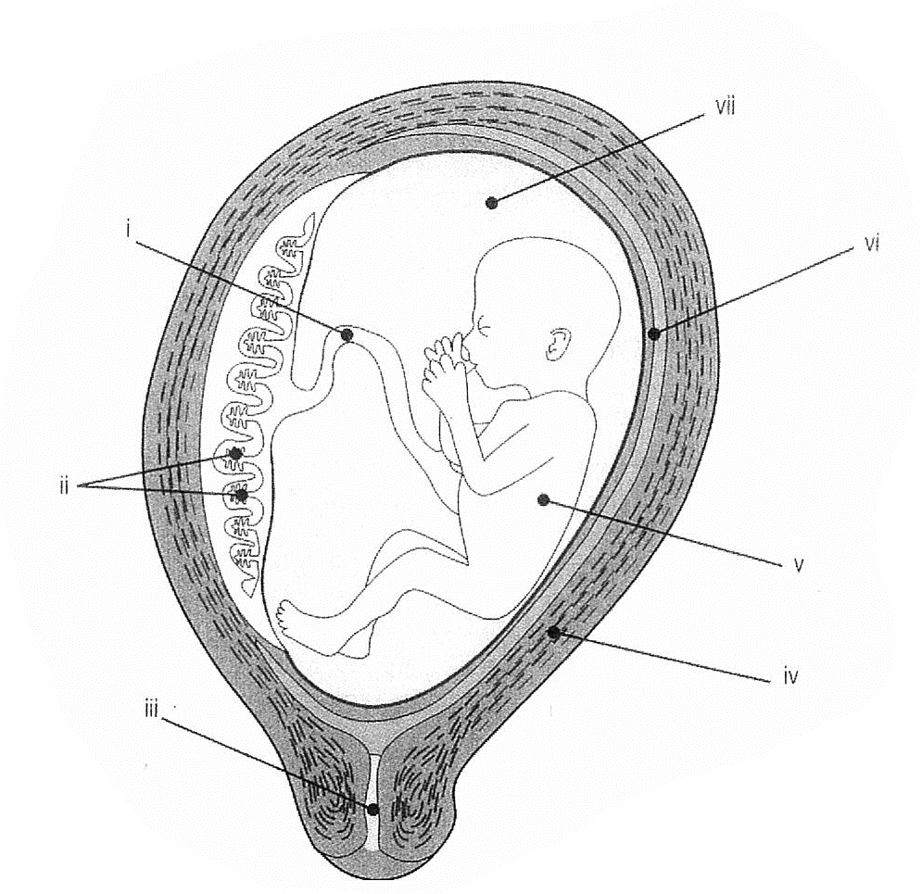

1. ______________________________________________

(ii) ______________________________________________

(iii) ______________________________________________

(iv) ______________________________________________

(v) ______________________________________________

(vi) ______________________________________________

(vii) ______________________________________________

6. (4 marks)

Describe the function of the following parts from the diagram in Question 5:

(ii) ____________________________________________________________________

______________________________________________________________________________________________________________________________________________

(vii) ___________________________________________________________________

______________________________________________________________________________________________________________________________________________

7. (4 marks)

Complete the following table by assigning a month (2-9) to each stage of foetal development.

|  |  |
| --- | --- |
| **Month** | **Stage of foetal development** |
|  | Fine hairs cover body; gripping reflexes are developing; increased growth. |
|  | Period of greatest growth; all systems functional except respiratory system. |
|  | Forelimbs well developed; eyelids closed; outer ear completed; bone marrow formed; blood cells formed in bone marrow; sex distinguishable. |
|  | Arm and leg buds appear and develop; enlarged head; all organs present. |
|  | Accumulation of fat beneath the skin; growth slowed. |
|  | Respiratory movements; digestive glands begin to function; tooth buds evident; eyebrows and eyelashes. |
|  | Eyes open; nose well formed; sucking and grasping reflexes apparent; fine body hair is shed. |
|  | Arms and hands fully shaped; skeleton completed; exercising of muscles evident; ears stand out from head. |

8. (3 marks)

For each of the stages of labour below, describe the defining event;

1st Stage: _______________________________________________________________

2nd Stage _______________________________________________________________

3rd Stage: _______________________________________________________________

9. (4 marks)

List four advantages of breastfeeding.

(i) _____________________________________________________________________

(ii) ____________________________________________________________________

(iii) ____________________________________________________________________

(iv) ____________________________________________________________________

10. (6 marks)

Motor development in an infant follows three patterns. Name and describe each of these patterns of development.

___________________________________________________________________________________________________________________________________________________________________________________________________________________________________________________________________________________________________________________________________________________________________________________________________________________________________________________________________________________________________________________________________________________________________________________________________________________________________________________________________________________________________________________________________________________________________________________________________________________________________________________________________________________________________________________________________________________________________________________________________________________________________________________________________________________________________________________________________________________________________________________________________________________________________________________________________________________________________________________________________________________________________________________________________________________________________________________________________________________________________________________________________________________

END OF TEST